Ornithology BIO-460

Vocalization Assignment

**Having discussed stress physiology on birdsong and behavior of *Passeriformes*, complete the following:**

1. **Examine the spectrograph in Figure 1. Determine the call notes listed and label them above each note (NOTE: call notes will be A, B, C, or D)**
2. **Write a scenario that would elicit each note type. (HINT: Does the note correlate with breeding socialization? Does it correlate with predator-response? Is it a signaler or response note?).**
3. **List the genus, species, and common name of the songbird in the photo.**
4. **List the range, phenotypic characters, as well as 1 nuclear habitat species for this bird (HINT: grey falcon, white-breasted nuthatch, etc).**

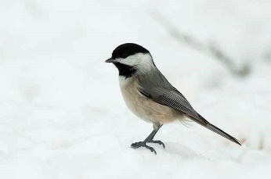 Bird:_____________________________________________________

Source: http://www.birdsandblooms.com/blog/birding-basics-chickadee-identification-challenge/

Figure 1: Call notes displayed at frequency on a spectrograph

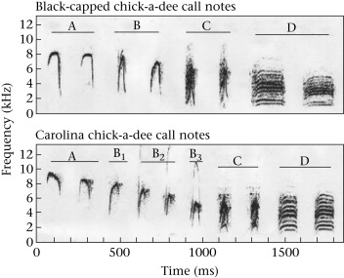 Source: https://fsuornithology.wordpress.com/2011/12/10/the-carolina-chickadee-godfather-of-the-forest/